Input:

using System;

namespace Computer_Programming_Lab_08

{

class Program

{

static void Main(string[] args)

{

int m = 5; //Rows

int n = 4; //Col

string[,] profile = new string[m, n];

//titles

profile[0, 0] = "Name";

profile[0, 1] = "Phone No";

profile[0, 2] = "Designation";

profile[0, 3] = "Department";

//row 1

profile[1, 0] = "Abdullah";

profile[1, 1] = "000000000";

profile[1, 2] = "Jr.Dev";

profile[1, 3] = "BSE";

//row 2

profile[2, 0] = "Shahzaib";

profile[2, 1] = "000000000";

profile[2, 2] = "Sr.Dev";

profile[2, 3] = "BSCS";

// Printing of 2D Array

for (int i =0; i<m; i++)

{

for (int j = 0; j < n; j++)

{

Console.Write("{0}\t\t",profile[i,j]);

}

Console.WriteLine();

}

}

}

}

Output:

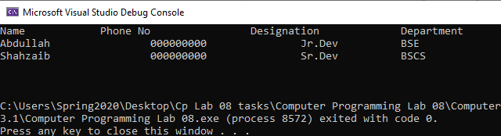

Input:

using System;

namespace Computer_Programming_Lab_08

{

class Program

{

static void Main(string[] args)

{

int m = 5; //Rows

int n = 4; //Col

string[,] profile = new string[m, n];

//titles

profile[0, 0] = "Name";

profile[0, 1] = "Phone No";

profile[0, 2] = "Designation";

profile[0, 3] = "Department";

for (int i =1; i<m; i++)

{

for (int j = 0; j < n; j++)

{

if (j == 0)

{

Console.WriteLine("Enter name");

profile[i, j] = Console.ReadLine();

}

else if (j == 1)

{

Console.WriteLine("Enter phone Number");

profile[i, j] = Console.ReadLine();

}

else if (j == 2)

{

Console.WriteLine("Enter Designation");

profile[i, j] = Console.ReadLine();

}

else

{

Console.WriteLine("Enter Department");

profile[i, j] = Console.ReadLine();

}

}

Console.WriteLine("Enter Profile {0}", i+2);

}

Console.WriteLine("/n++++++++++Profile Summry++++++++++");

for (int i = 1; i < m; i++)

{

for (int j = 0; j < n; j++)

{

Console.WriteLine("{0}", profile[i,j]);

}

}

}

}

}